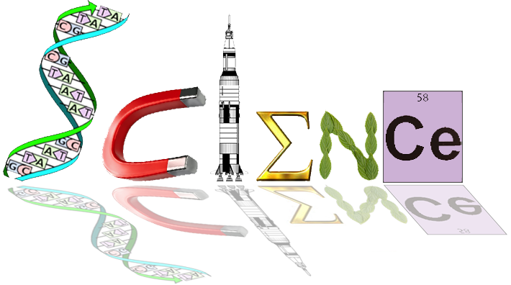

**Human Biology Year 12 – Task 6**

**Homeostasis and Dysfunction – Extended Response**

Background:

You have recently joined a celebrated Stanford University research team, headed by Hiromitsu Nakauchi, MD, PhD, and have been charged with recruiting research participants into a new clinical trial. This team recently reversed cases of type 1 diabetes mellitus in mice. This involved growing pancreases using mouse stem cells inside healthy rats, then transferring the pancreatic islets back into diabetic mice. The medical community, suffers of diabetes, and the media have shown keen interest in this work. However, phase 1 clinical trials must be undertaken to establish the safety of this procedure for humans.

Task:

You must develop and infographic to effectively summarise this research to potential participants and recruit them into the trial. This will require you to cover the following topics, in a succinct and accurate manner:

* The role of insulin and the pancreas in type 1 diabetes mellitus
* Symptoms and complications of type 1 diabetes mellitus
* An overview of stem cell therapy and its potential for type 1 diabetes mellitus
* An overview of gene therapy and its potential for type 1 diabetes mellitus
* A summary of the initial animal research project and its findings
* Ethical considerations (risks and opportunities)

Please note that all work must be cited using a consistent style (eg. [Vancouver](http://guides.library.uwa.edu.au/friendly.php?s=vancouver) or [Harvard](http://guides.library.uwa.edu.au/friendly.php?s=harvard))

Resources:

The following link provides access to a summary of the original research: <http://scopeblog.stanford.edu/2017/01/25/rat-grown-mouse-pancreases-reverse-diabetes-in-mice-say-researchers/>

Further resources, including the original article, are available through our Connect Library.

Marking Key:

|  |  |  |  |  |  |
| --- | --- | --- | --- | --- | --- |
|  | 0 | 1 | 2 | 3 | Mark |
| 1.  Role of the pancreas and insulin in type 1 diabetes mellitus | Identification of the role of the pancreas and insulin in type 1 diabetes mellitus, missing multiple aspects of the glucose feedback loop or key structures. | Description of the role of the pancreas and insulin in type 1 diabetes mellitus, including the most aspects of the glucose feedback loop and key structures. | Detailed description of the role of the pancreas and insulin in type 1 diabetes mellitus, including accurate description of the glucose feedback loop and all key structures. | Explanation of the role of the pancreas and insulin in type 1 diabetes mellitus, including accurate explanation of the glucose feedback loop and all key structures. | /3 |
| 2.  Symptoms and complications of type 1 diabetes mellitus | Identification of some key symptoms and complications of type 1 diabetes mellitus only . | Description of most key symptoms and complications of type 1 diabetes mellitus. | Detailed description of all key symptoms and complications of type 1 diabetes mellitus. | Detailed description of all key symptoms and complications of type 1 diabetes mellitus, ands explanation of its social, emotional and physical effects. | /3 |
| 3. Overview of stem cell therapy and its potential for type 1 diabetes mellitus | Identification of some aspects of the process of stem cell therapy and or how it can be applied to type 1 diabetes mellitus. | Description of most aspects of the process of stem cell therapy and identification of how it can be applied to type 1 diabetes mellitus. | Detailed description of the process of stem cell therapy and description of how it can be applied to type 1 diabetes mellitus. | Detailed explanation of the process of stem cell therapy and explanation of how it can be applied to type 1 diabetes mellitus. | /3 |
| 4. Overview of gene therapy and its potential for type 1 diabetes mellitus | Identification of some aspects of the process of gene therapy and or how it can be applied to type 1 diabetes mellitus. | Description of most aspects of the process of gene therapy and identification of how it can be applied to type 1 diabetes mellitus. | Detailed description of the process of gene therapy and description of how it can be applied to type 1 diabetes mellitus. | Detailed explanation of the process of gene therapy and explanation of how it can be applied to type 1 diabetes mellitus. | /3 |
| 5. A summary of the initial animal research project and its findings | Limited or no accurate description of the initial animal research project and its findings. | Some accurate description of the initial animal research project and its findings. | Detailed description of the initial animal research project and its findings. | Detailed explanation of the initial animal research project and its findings. | /3 |
| 6. Ethical considerations (risks and opportunities) | Limited or no accurate description of the ethical risks and opportunities for participants. | Some accurate description of the ethical risks and opportunities for participants. | Detailed description of the ethical risks and opportunities for participants. | Detailed explanation of the ethical risks and opportunities for participants. | /3 |
| Infographic presentation | The infographic is disorganised  with no identifiable format and little visual appeal. Numerous errors in syntax, grammar or spelling. | The infographic has some headings and/or structure and some effective visual material is used. Some errors in syntax, grammar or spelling. | The infographic has some logical structure and/ or headings. Most visual material is effective in appealing to readers and facilitating understanding. Few errors in syntax, grammar or spelling | The infographic has consistently clear and logical structure and headings. Visual material is consistently effective in appealing to readers and facilitating understanding. No errors in syntax, grammar or spelling | /3 |
| References | Little effort made to reference - unclear format or incomplete references | Three sources are used and cited completely and in a mostly consistent and clear format | Four reliable sources are used and cited in a consistent and clear format | Four or more reliable sources are used and cited in a consistent and clear format | /3 |